**Mentor On Demand – IIHT Certification**

**Associate Name:** Kaarthikeyan R

**Batch Id:** CHN19ID004

**Employee Id:** 808002

**Contents:**

* Repository Link
* Angular UI Screenshots
* Postman Endpoint Test Screenshots
* Jenkins CI/CD Screenshots
* JMeter Test Screenshots

1. **Repository Link**

**GitHub Link -** <https://github.com/kragh-dev/IIHT_Mentor_On_Demamd_Project.git>

1. **Angular UI Screenshots**

**Before Login**

**Home Page**

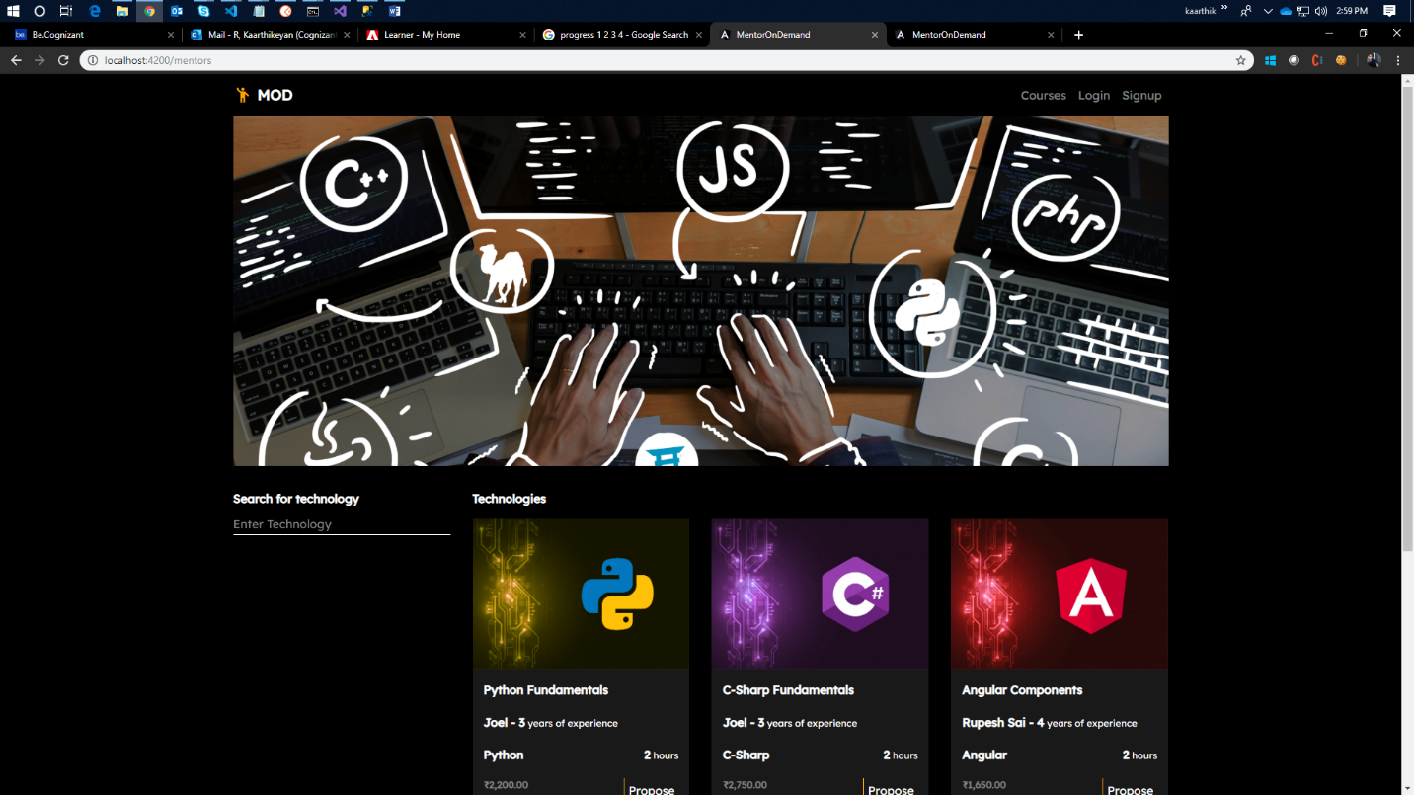

**Search (based on technology)**

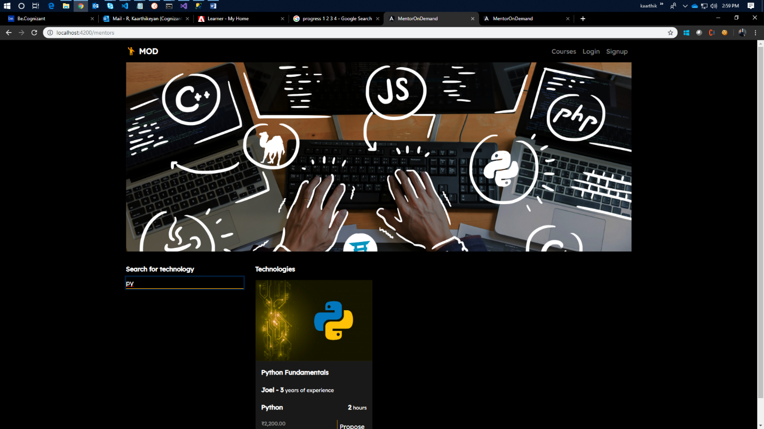

**Login Page Main Screen**

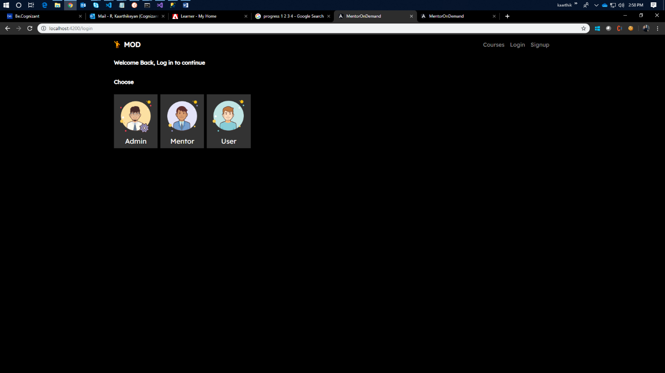

**Login Form**

1. **Admin**

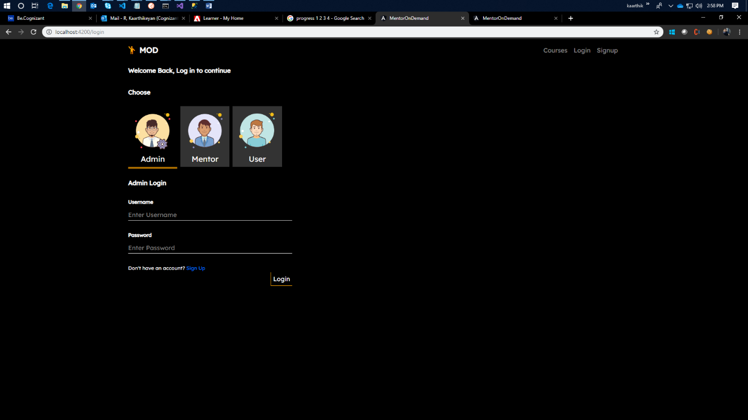

1. **Mentor**

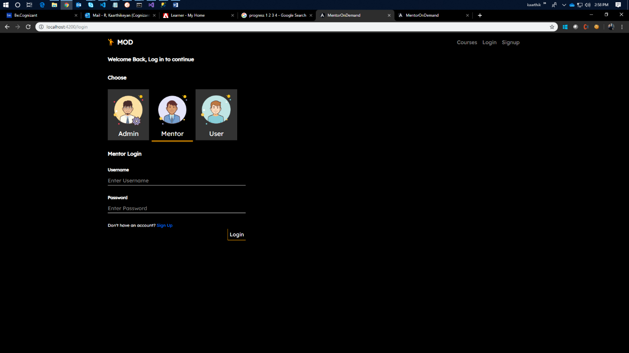

1. **User**

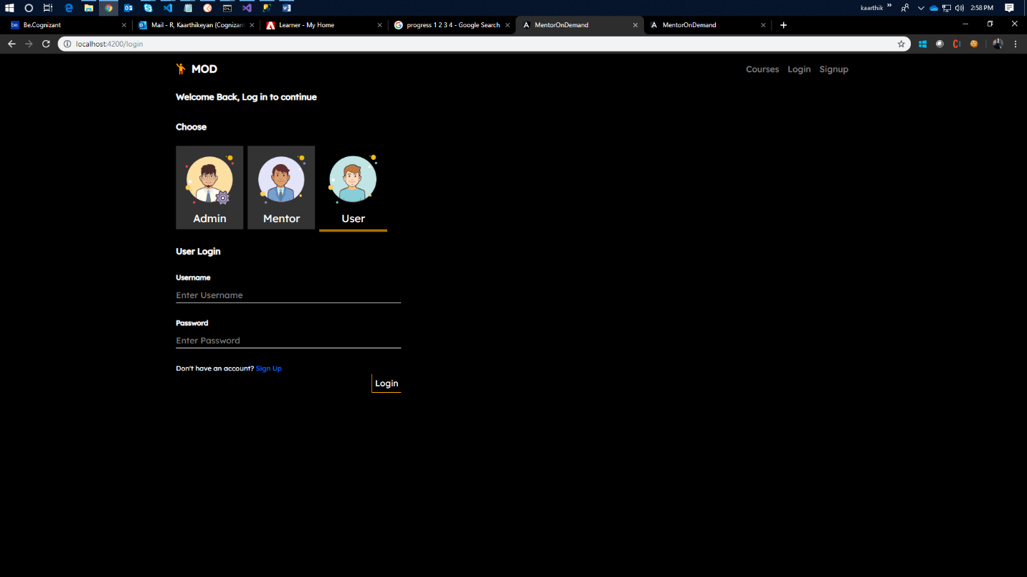

**Signup Page Main Screen**

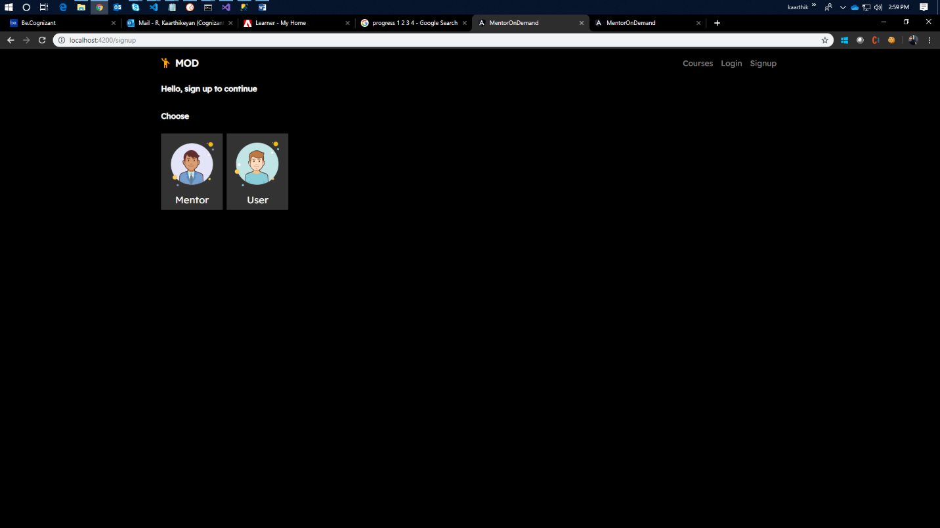

1. **Mentor**

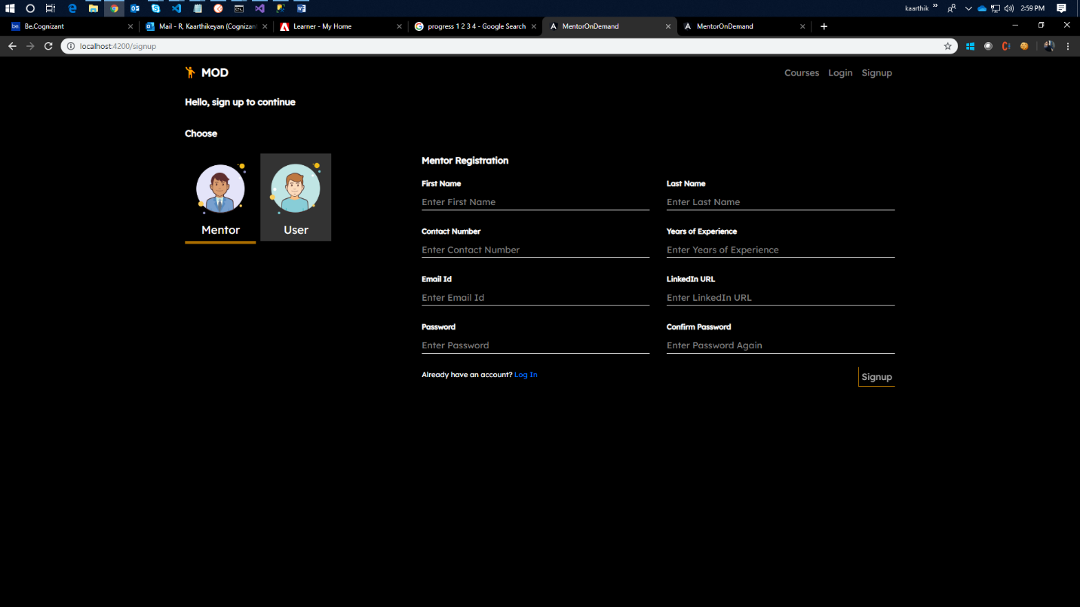

1. **User**

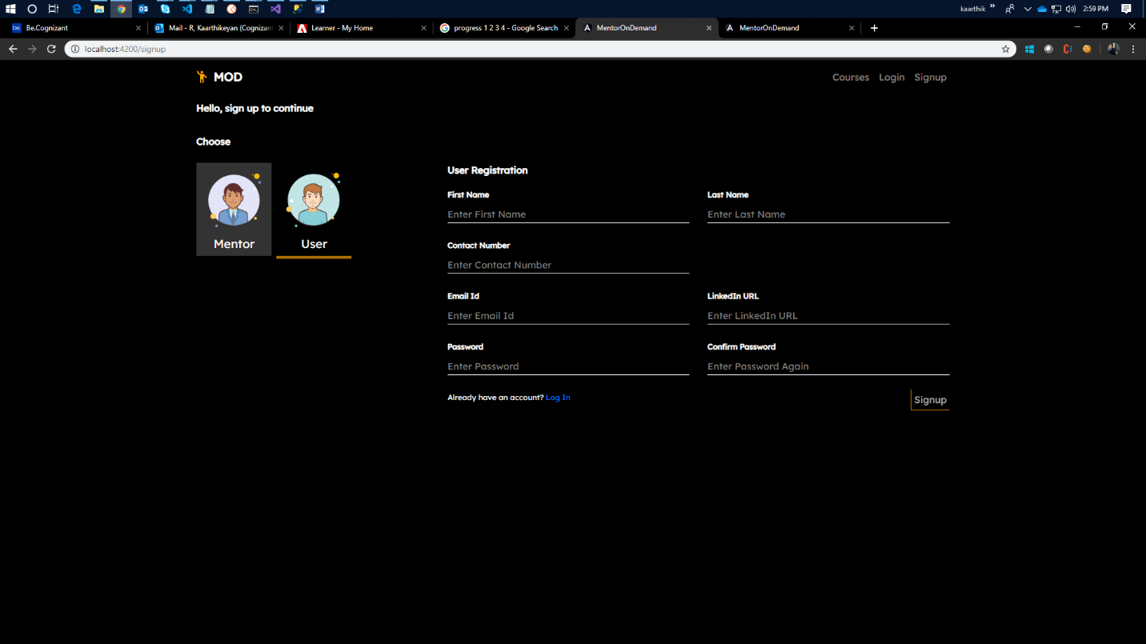

**After Mentor Login**

**Mentor Courses**

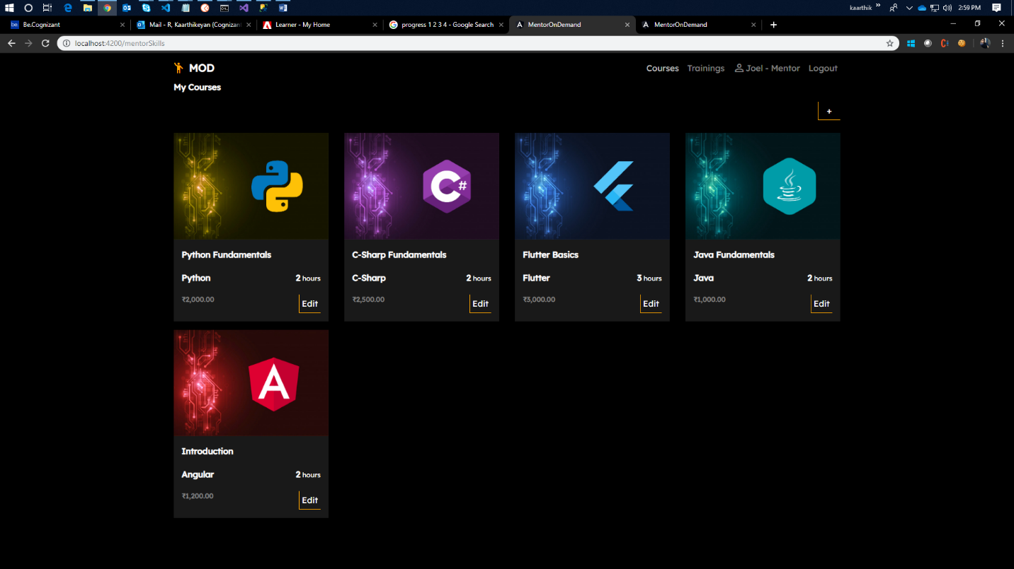

**Add Course Form**

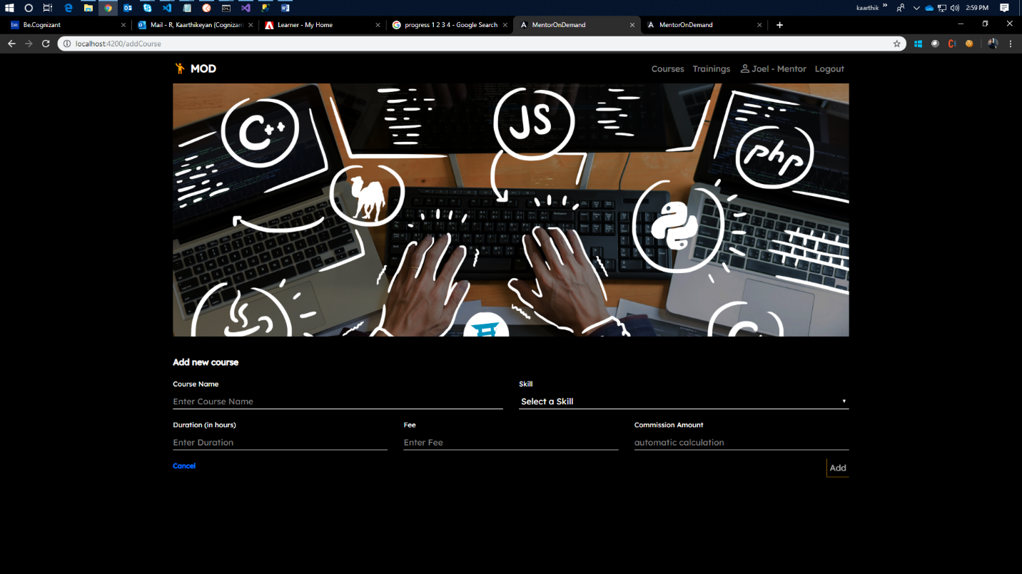

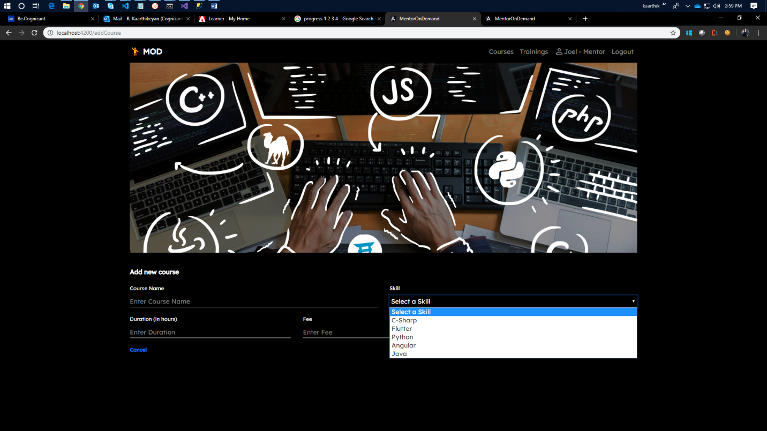

**Users who have requested access**

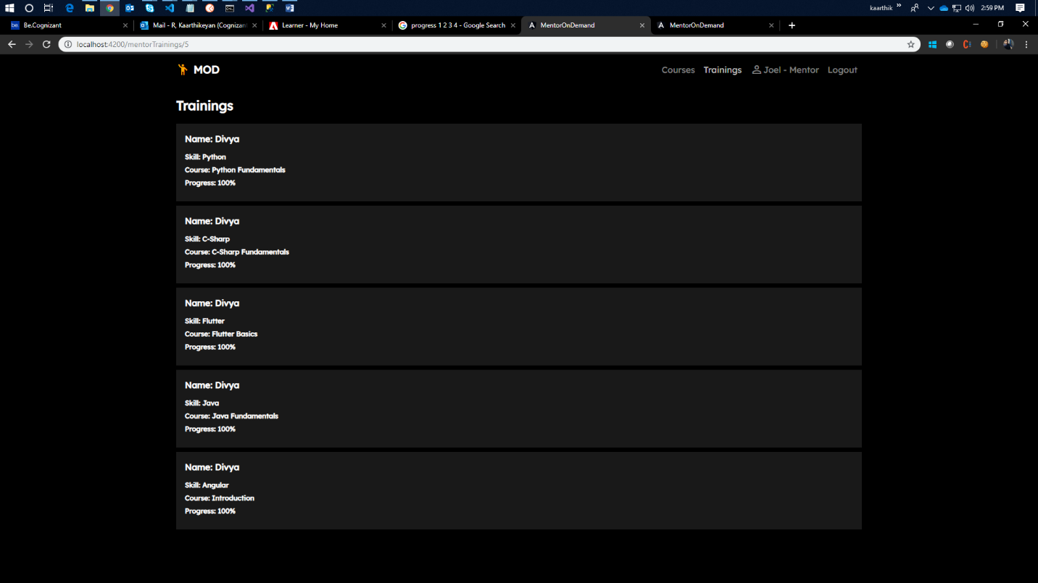

**After User Login**

**User Home Mentor Search**

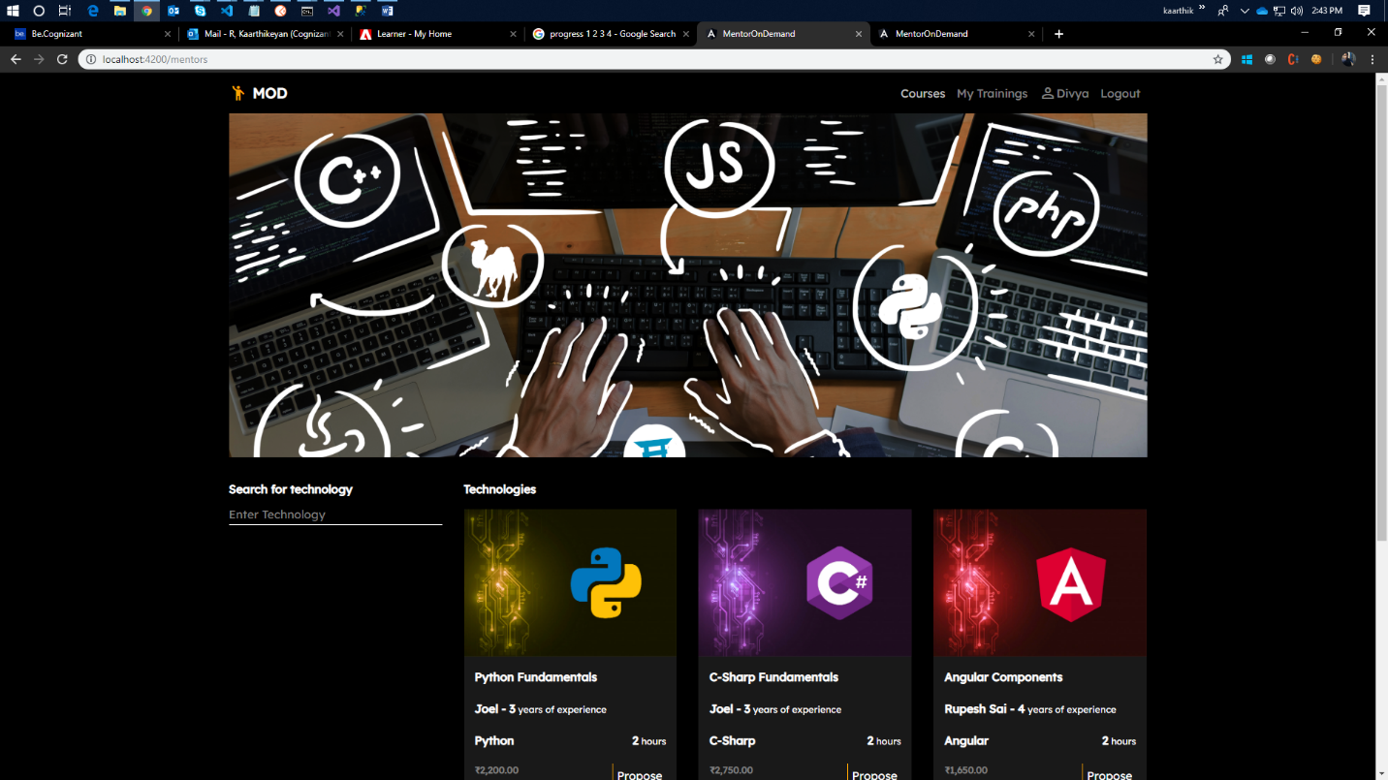

**User Trainings**

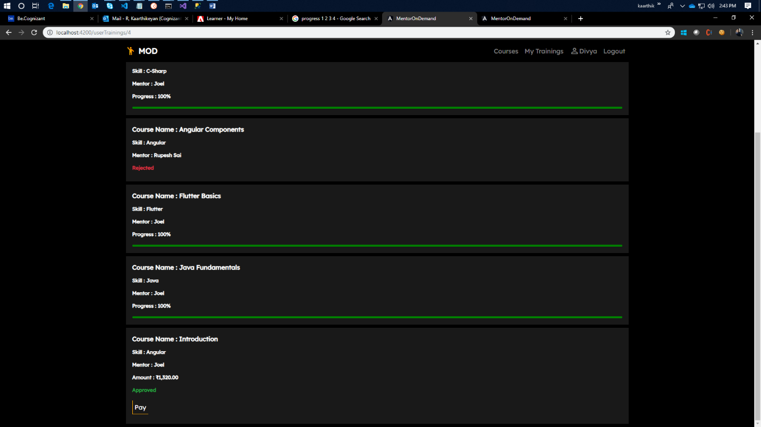

**User Course Progress**

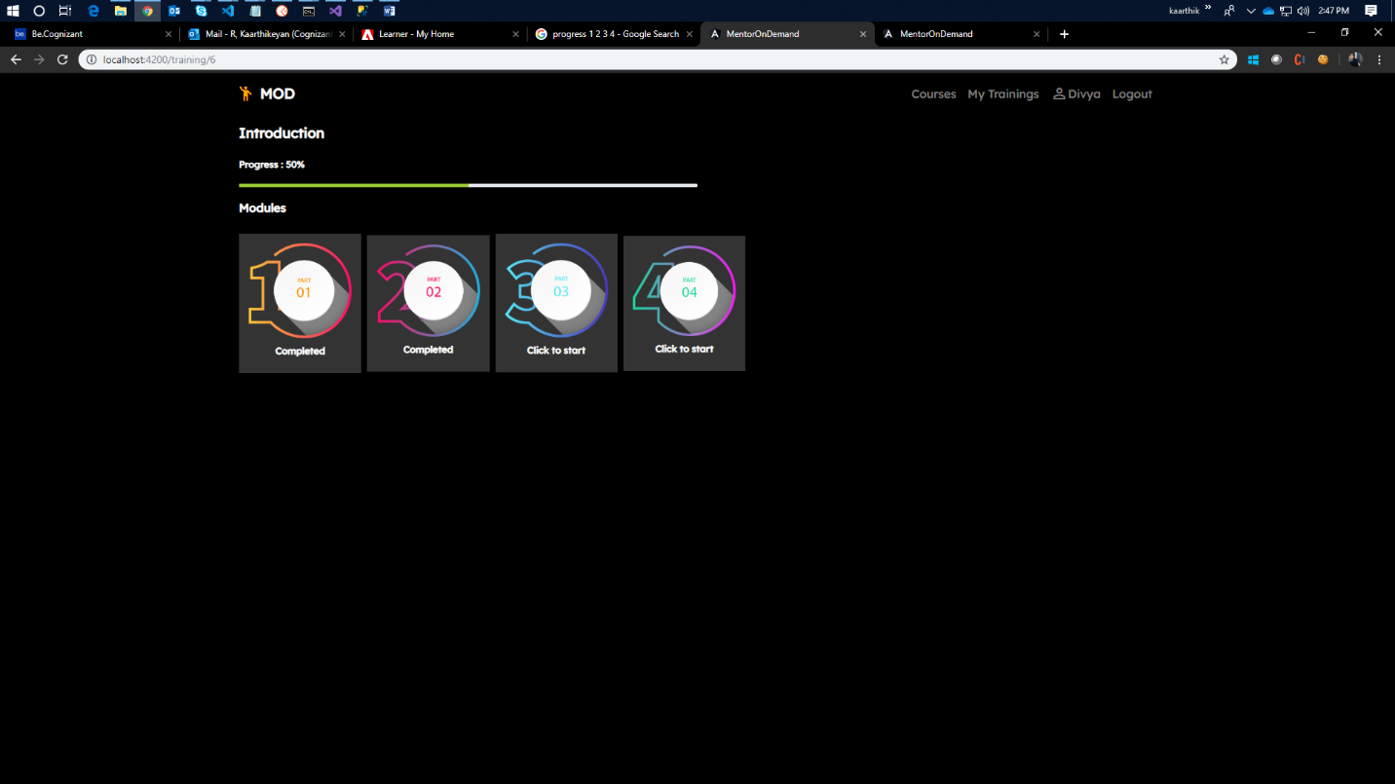

1. **Postman Endpoint Test Screenshots**

**Mentor Endpoints**

addCourse()

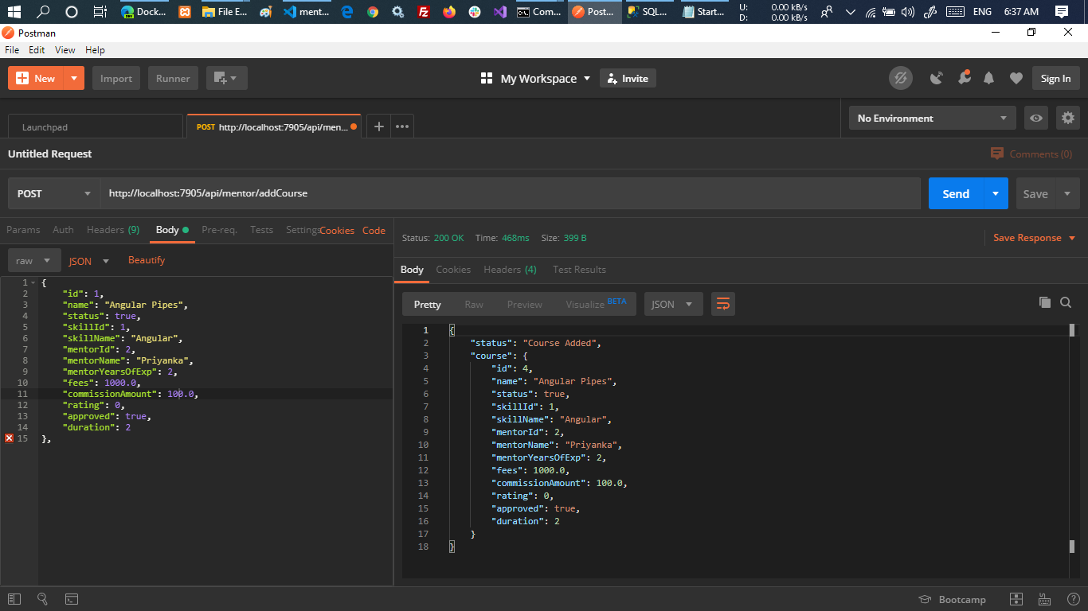

getCoursesById(id)

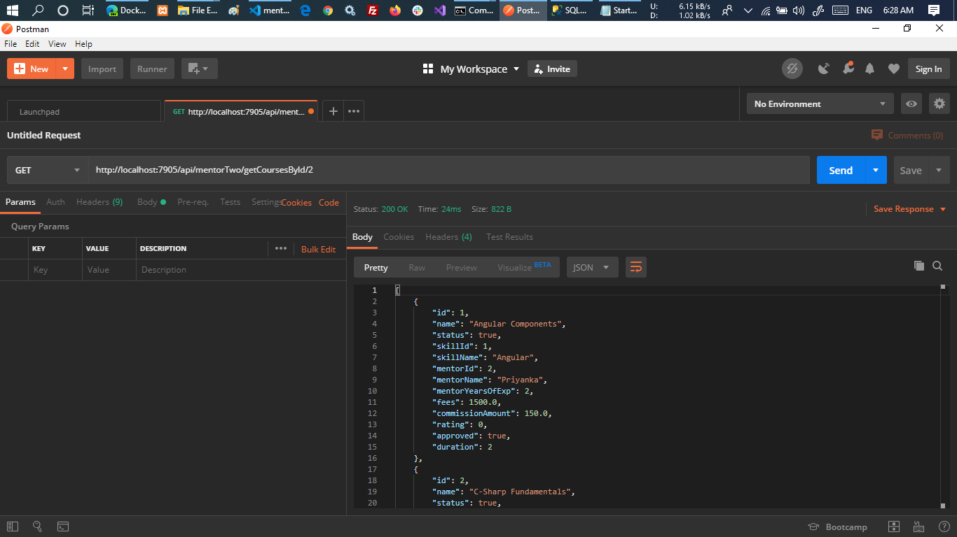

getMySubscriber(id)

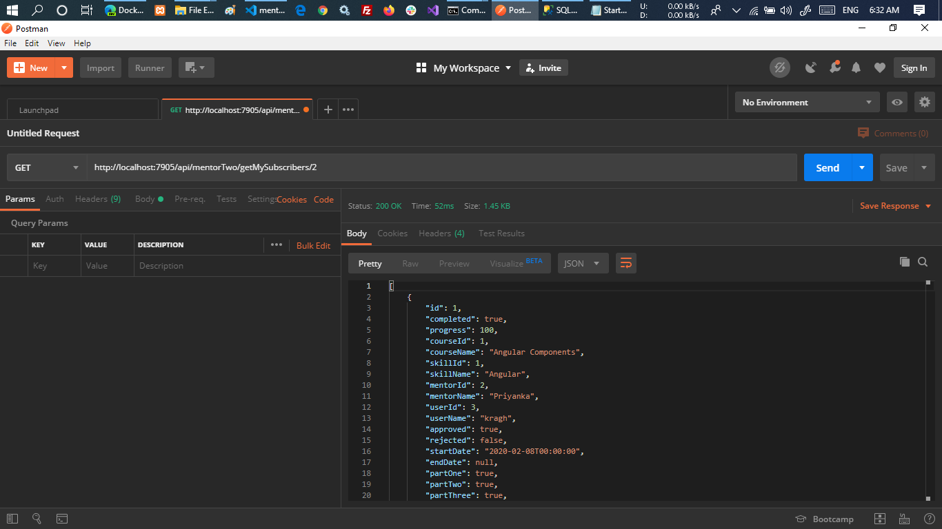

getSkills()

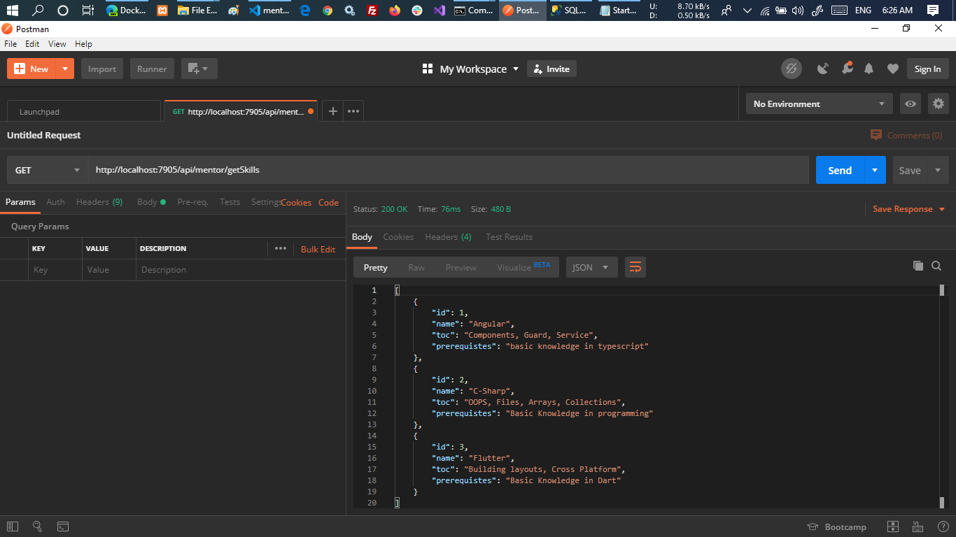

updateTrainingStatus(id,status)

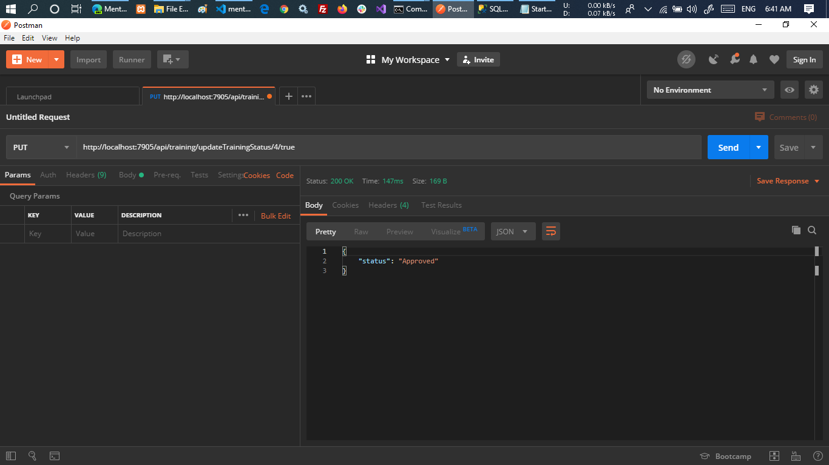

**User**

completeTraining(id,progress)

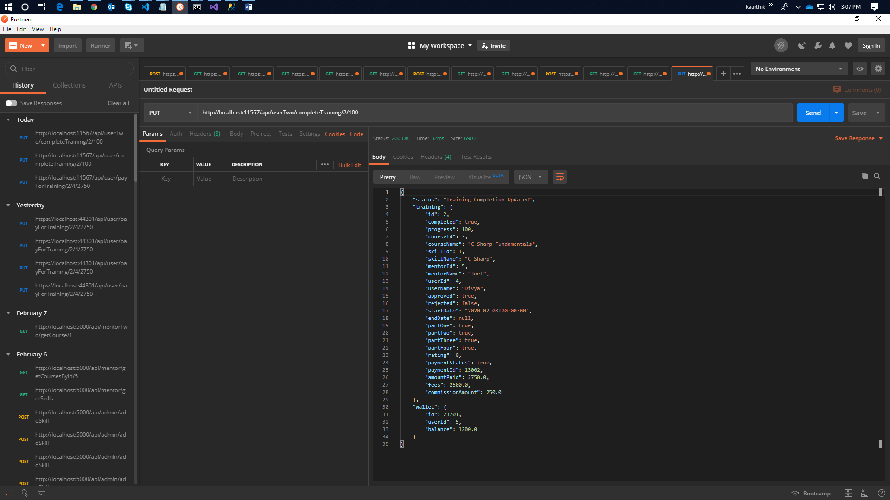

getCourses()

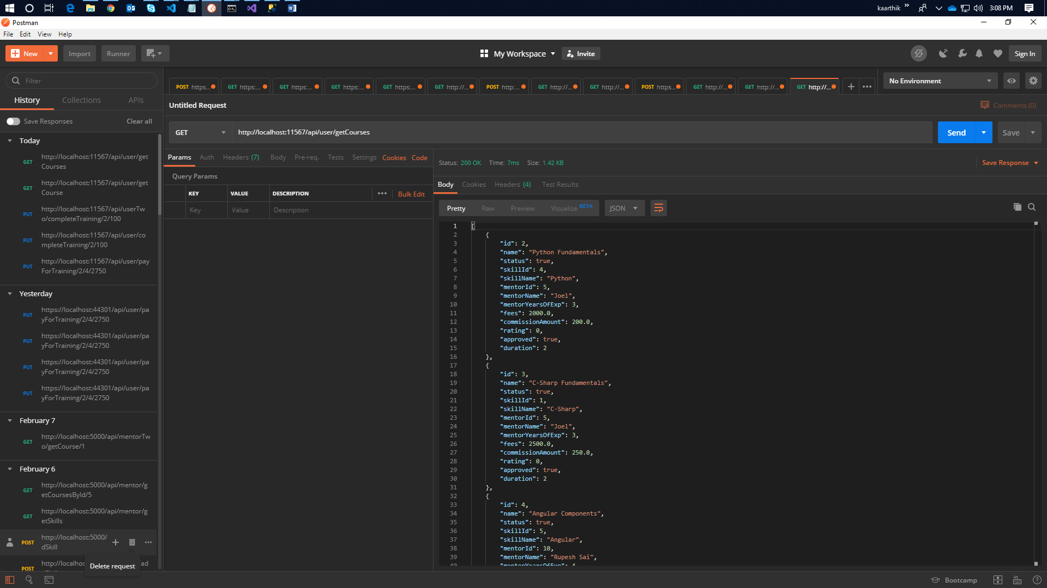

getMyTrainings(id)

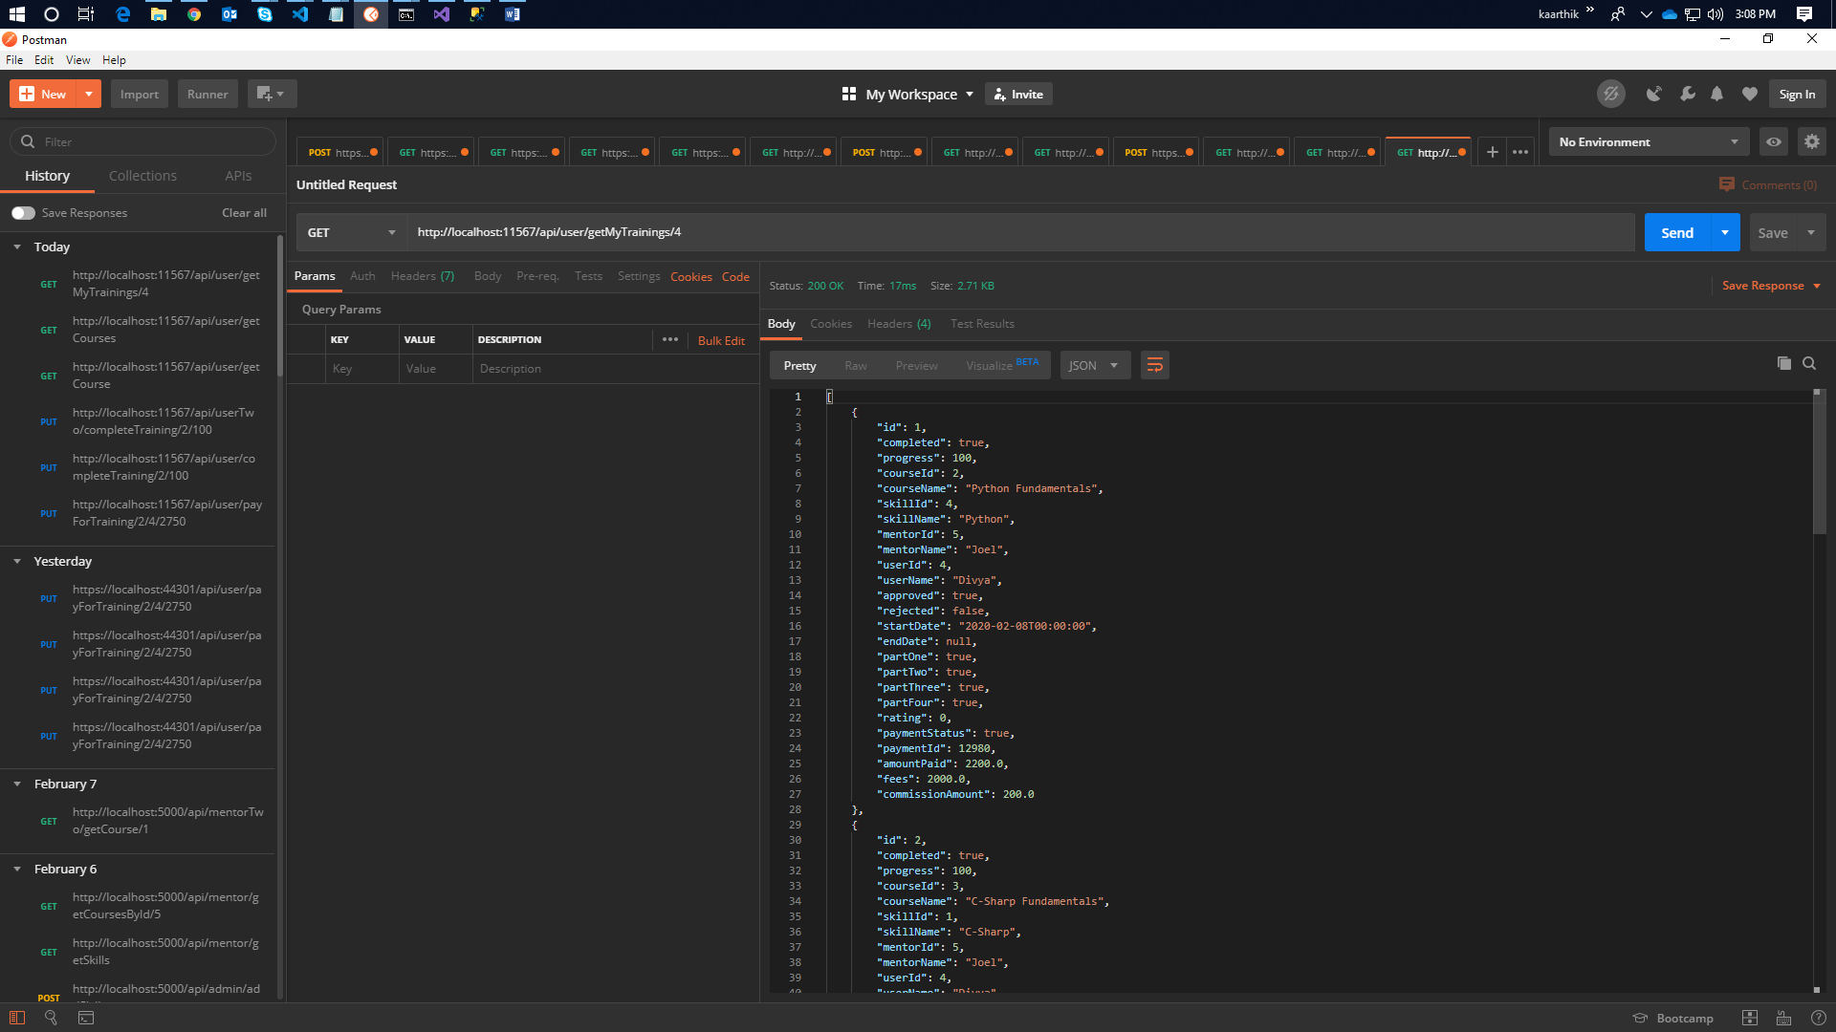

getTraining(id)

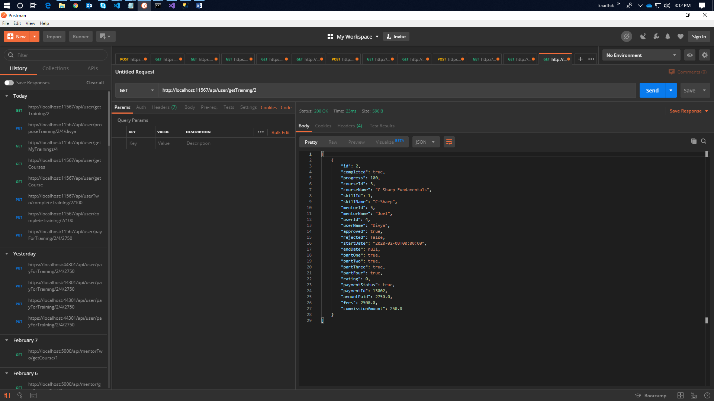

payForTraining(id, userId, amount)

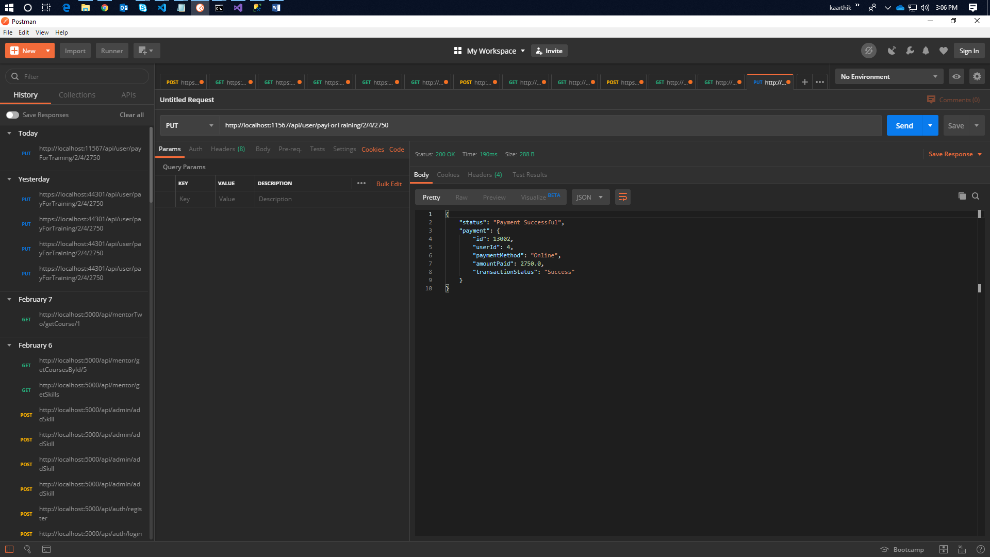

proposeTraining(id,userId,userName)

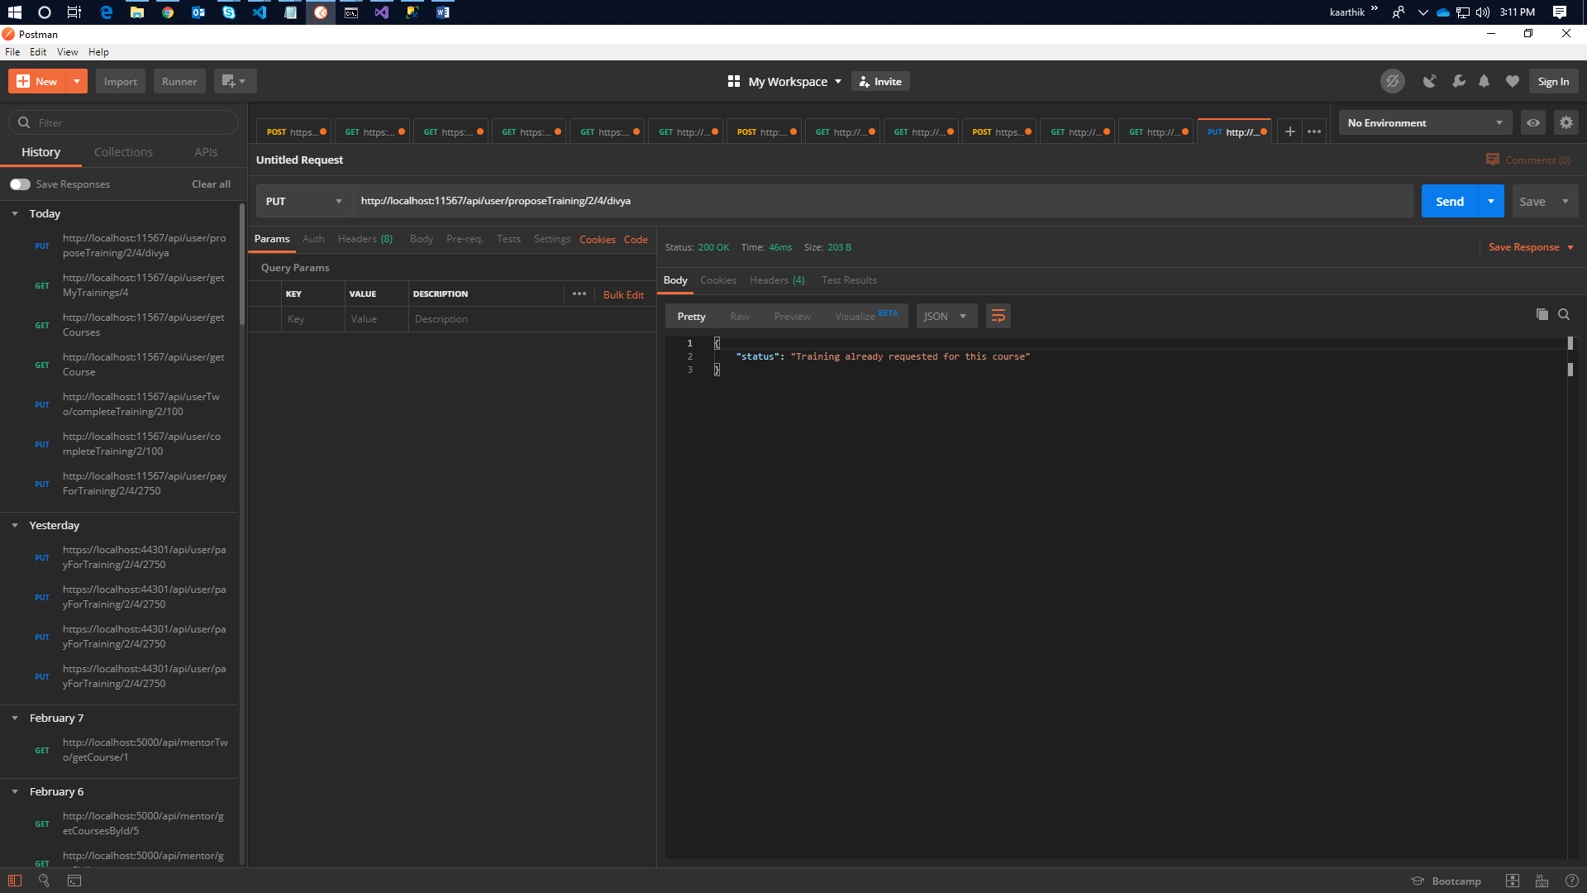

1. **Jenkins CI/CD Screenshots**

**Dashboard**

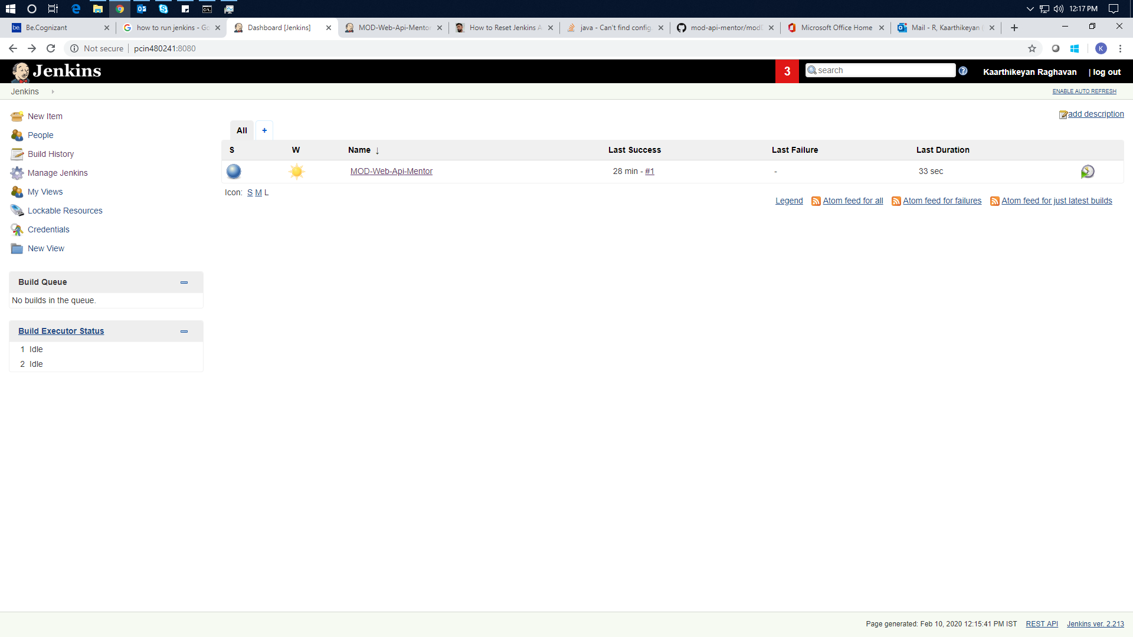

**Project View**

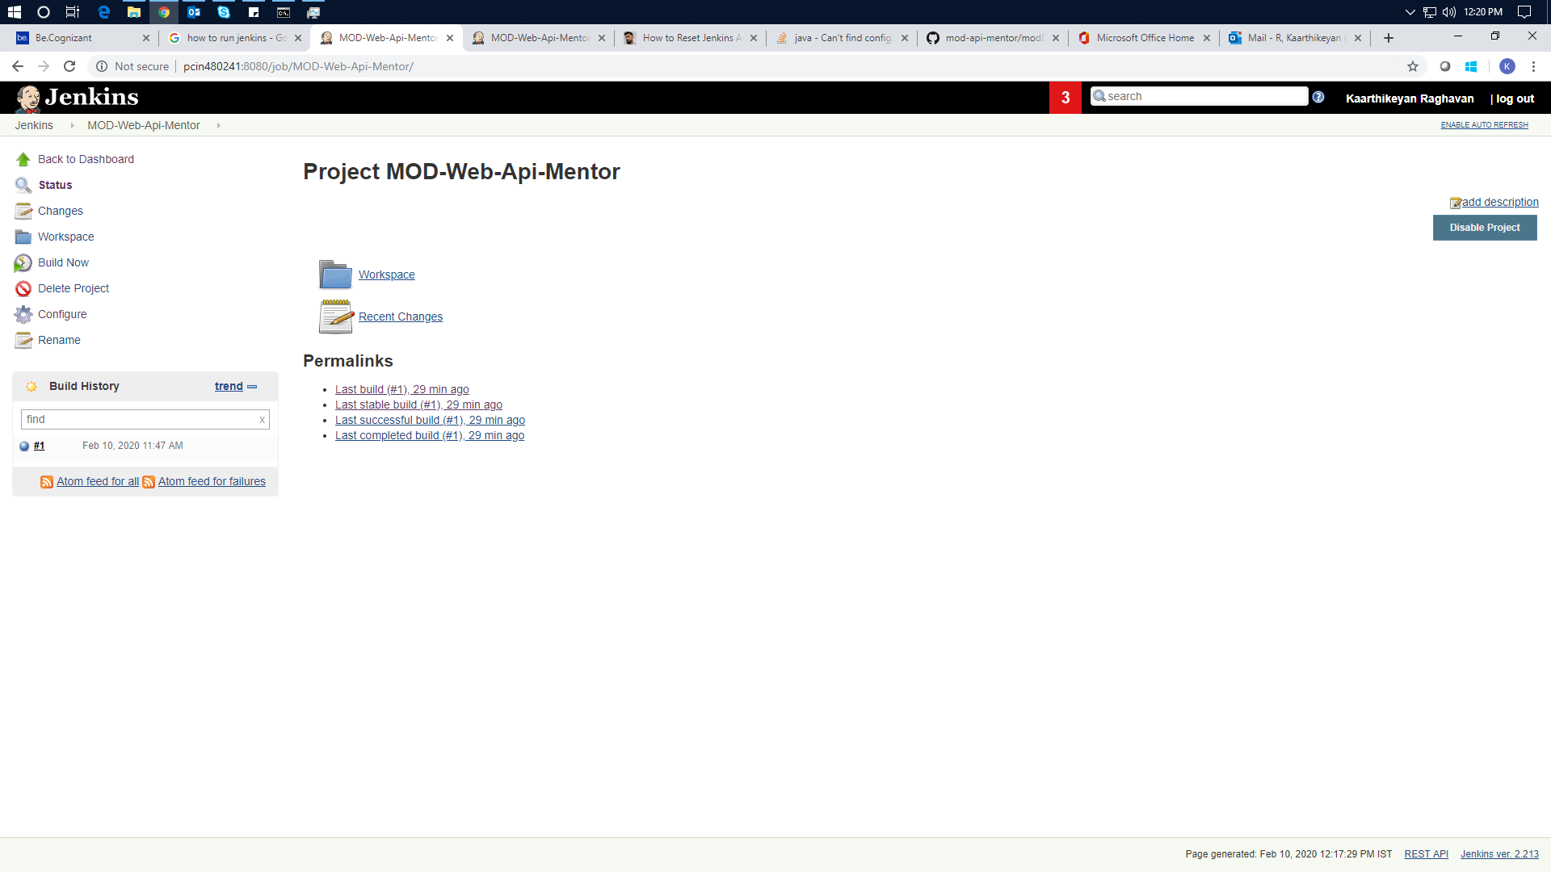

1. **JMeter Test Screenshots**

**Test Plan**

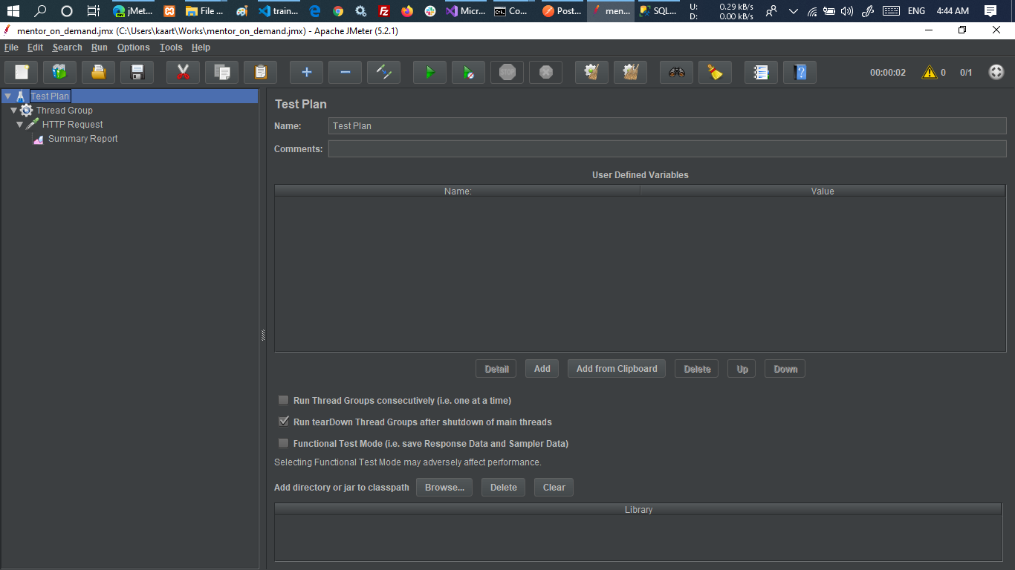

**Threads**

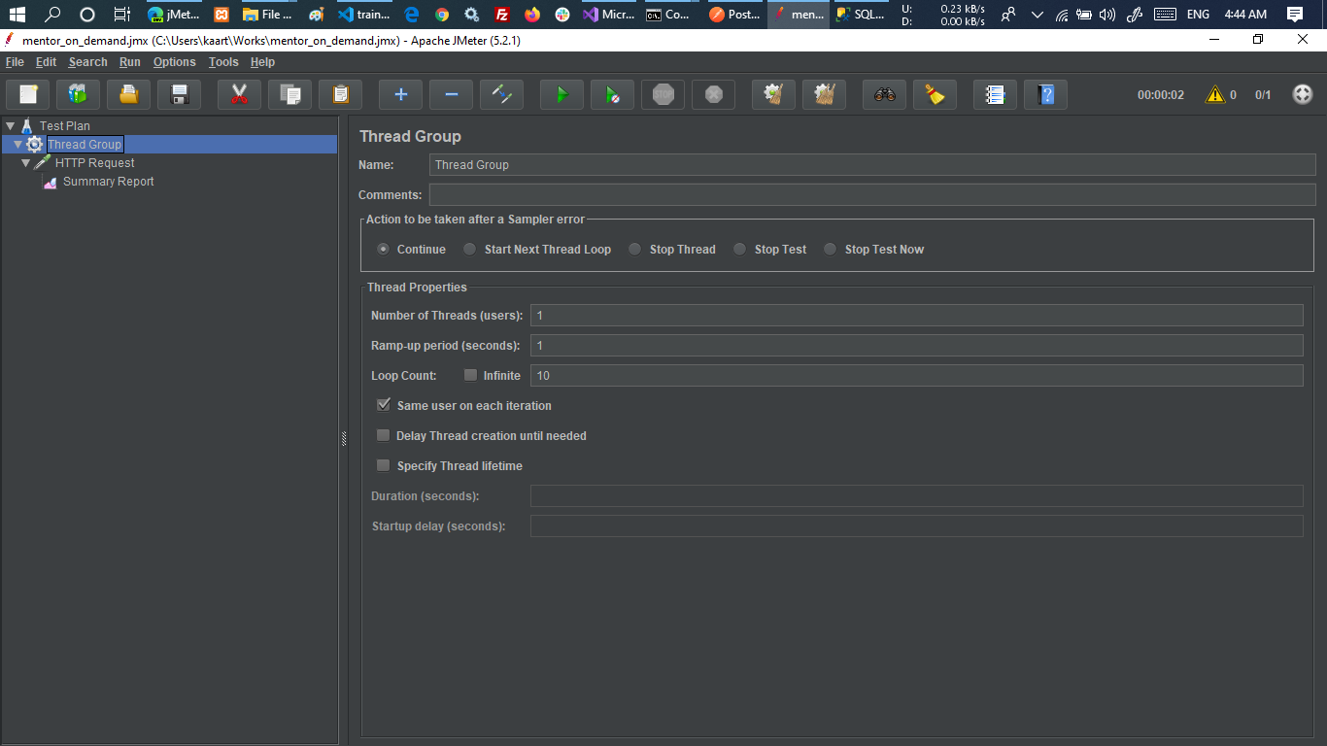

**HttpRequest**

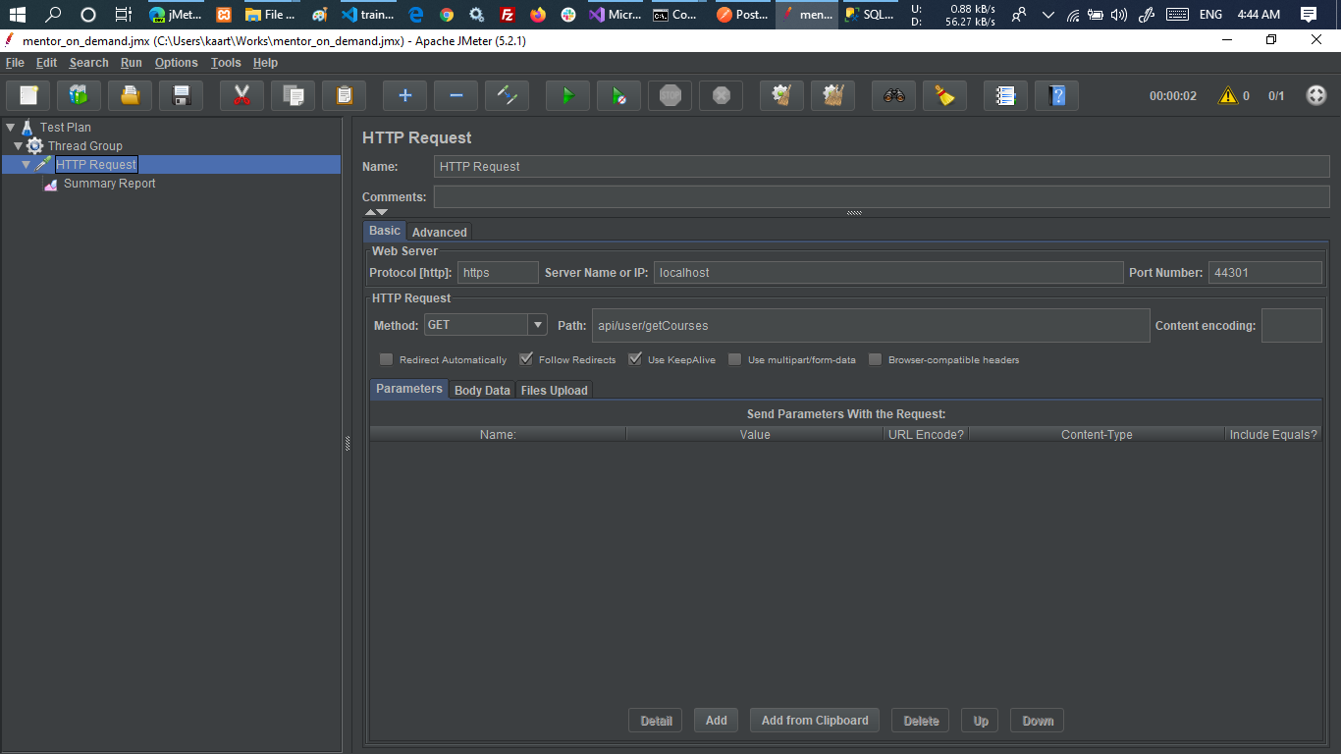

**Summary Report**

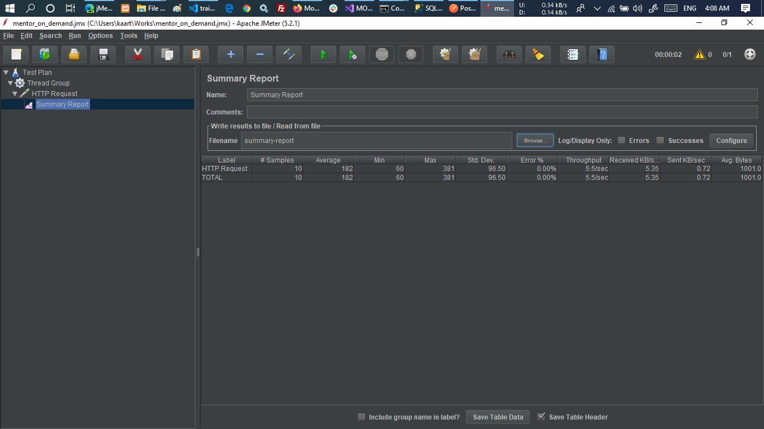

**Readme Note:** Admin functionality is optional so didn’t implementso if you try to login it will show alert as that is under build